**Pizza Sales SQL- quries**

**Check No. of Rows**

Query:

SELECT Count (*)

FROM pizza;

Result:

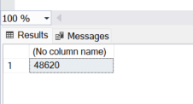

**Check number of Columns**

Query:

SELECT COUNT (*)

FROM INFORMATION_SCHEMA.COLUMNS

WHERE Table_Name = 'pizza';

Result:

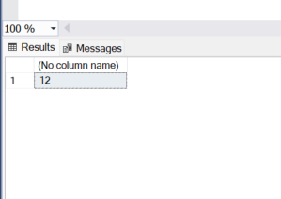

**Create Backup_Table**

Query:

SELECT * INTO New_Table FROM pizza;

Result:



**How to safely Test (Alter Data)**

Query:

BEGIN TRANSACTION;

ALTER TABLE pizza ADD new_column int;

-- COMMIT ( to apply )

--ROLLBACK; (to Undo)

Result:

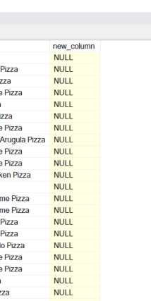

**Rename Table**

Query:

EXEC sp_rename 'pizza_sales', 'pizza';

Result:

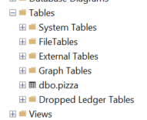

**Delete Table**

Query:

DROP TABLE Table_1;

Result:

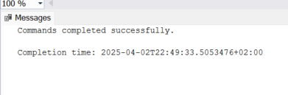

**Rename Column**

Query:

EXEC sp_rename 'pizza.pizza_nnme', 'pizza_name', 'column';

Result:

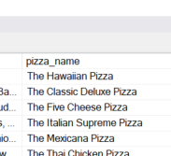

**Add column**

Query:

ALTER TABLE pizza ADD new_col int;

Result:

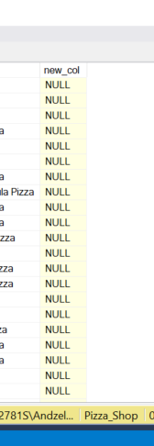

**INSERT values into COLUMN**

Query:

UPDATE pizza SET new_col = unit_price * quantity;

Result:

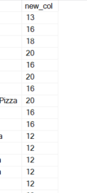

**Remove Column**

Query:

ALTER TABLE pizza ADD new_col int;

Result:

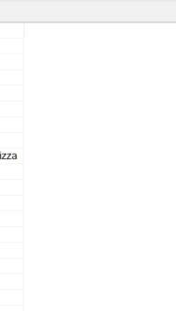

**Change Column Data Type**

Query:

ALTER TABLE pizza ALTER COLUMN unit_price int;

Result:

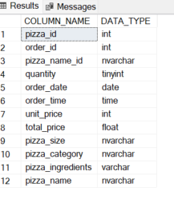

**Check Column names & Data types**

Query:

SELECT COLUMN_NAME, DATA_TYPE FROM INFORMATION_SCHEMA.COLUMNS WHERE TABLE_NAME = 'pizza';

Result:

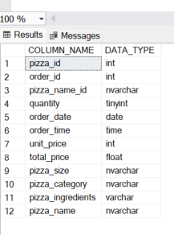

**Check NULL value in Column**

Query:

--There is no Null value in column 'quantity'

SELECT * from pizza

where quantity IS NULL;

**Total Revenue**

Query:

SELECT ROUND(SUM(total_price),0) AS Total_Revenue FROM pizza;

Result:

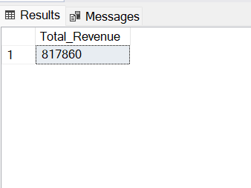

**Average Order Value**

Query:

SELECT

ROUND (SUM(total_price) / COUNT (DISTINCT order_id),0) AS average_order_value

FROM pizza;

Result:

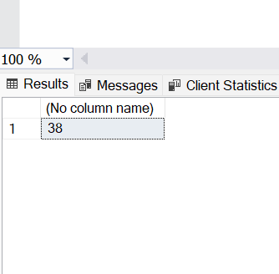

**Total Pizza Sold**

Query:

SELECT SUM(quantity) AS Total_Pizza_Sold FROM pizza;

Result:

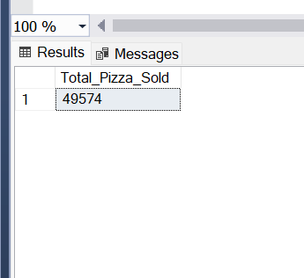

**Total Orders**

Query:

-- Orders are repeating so to just count one order once I used Distinct

SELECT COUNT(DISTINCT order_id) AS total_orders FROM pizza;

Result:

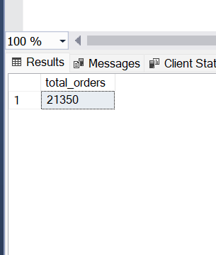

**Average Pizza Per Order**

Query:

SELECT

CAST(CAST(SUM(quantity) AS DECIMAL(10,2)) /

CAST(COUNT(DISTINCT order_id) AS DECIMAL(10,2)) AS DECIMAL(10,2))

AS Average_Pizza_Per_Order

FROM pizza;

Result:

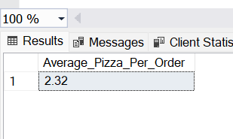

**Total orders by day of week**

Query:

SELECT

DATENAME(weekday,order_date) AS week_day,

COUNT(DISTINCT order_id) AS total_orders

FROM pizza

GROUP BY DATENAME(weekday,order_date);

Result:

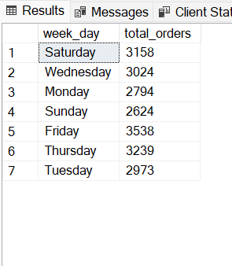

**Total Orders by Months**

Query:

SELECT

DATENAME(MONTH, order_date) AS Name_OF_Month,

COUNT(DISTINCT order_id) AS total_orders

FROM pizza

GROUP BY DATENAME(MONTH, order_date)

ORDER BY total_orders DESC;

Result:

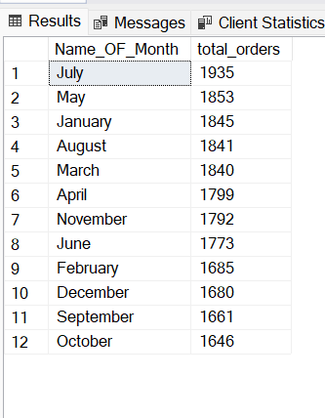

**Percentage of sale per pizza category**

Query:

SELECT

pizza_category,

ROUND((SUM(total_price) / (SELECT SUM(total_price) FROM pizza)) *100,2) AS PCT

FROM pizza

GROUP BY pizza_category;

Result:

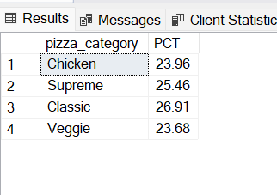

**Percentage of sale per pizza size**

Query:

SELECT

pizza_size,

ROUND(SUM(total_price) *100 / (SELECT SUM(total_price) FROM pizza), 2) AS pct

FROM pizza

GROUP BY pizza_size;

Result:

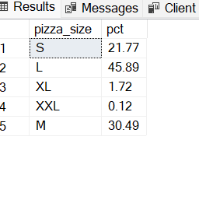

**Total pizza sold by category**

Query:

SELECT

pizza_category,

SUM(quantity) AS sold_Pizza

FROM pizza

GROUP BY pizza_category;

Result:

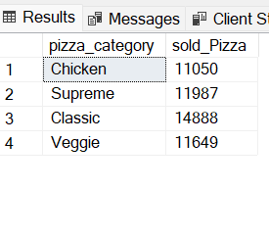

**TOP 5 pizza by revenue**

Query:

SELECT

TOP 5 pizza_name,

SUM(total_price) AS revenue

FROM pizza

GROUP BY pizza_name

ORDER BY revenue DESC;

Result:

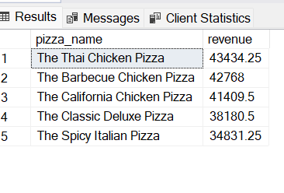

**Bottom 5 pizza (name) by revenue**

Query:

SELECT

TOP 5 pizza_name,

SUM(total_price) AS revenue

FROM pizza

GROUP BY pizza_name

ORDER BY revenue DESC;

Result:

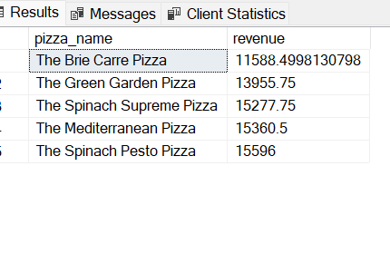

**Top 5 pizza by Quantity**

Query:

SELECT

TOP 5 pizza_name,

SUM(quantity) AS total_quantity

FROM pizza

GROUP BY pizza_name

ORDER BY total_quantity DESC;

Result:

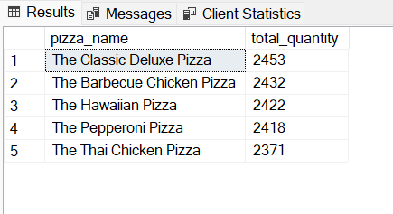

**Bottom 5 pizza by Quantity**

Query:

SELECT

TOP 5 pizza_name,

SUM(quantity) AS total_quantity

FROM pizza

GROUP BY pizza_name

ORDER BY total_quantity ASC;

Result:

